OSTEOARTHRITIS – updated Jan 2015

In this protocol, we will talk about management first (as that is what we most often need help with) and then talk about interesting things in diagnosis, x-rays, explanations and so on.

Before we do that, there is one things to say first. Our thinking about OA has changed. It is no longer seen as a wear and tear disease. Instead, see it as a wear, flare and repair process. This means that once OA starts, it doesn’t necessarily mean things will get bad for the patient from now on. Many are stable for years (and some even improve). More on this on page 3 of this protocol.

Management
NICE recommends a number of treatments of proven benefit for OA; summarised in the TARGET diagram below:
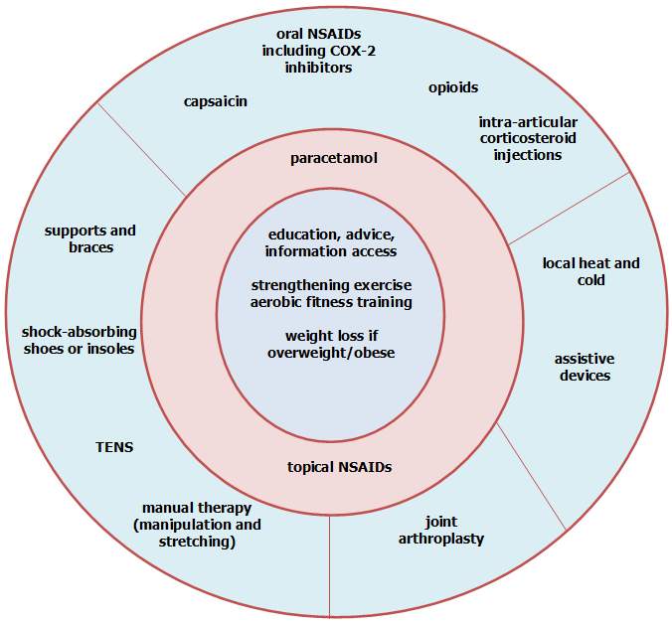
- Core treatments in the centre should be offered to all those with OA. It has been shown that increasing physical activity, undertaking exercises, and losing weight if needed have proven beneficial effects on pain and function
- Paracetamol and topical NSAIDs are recommended for use as 1st line analgesics
- The options in the outer circle should be considered for patients with ongoing pain and/or disability
- Remember that any one single intervention is unlikely to be effective alone. Combined treatments should be considered, e.g. physiotherapy plus analgesia plus a splint

Exercise: Muscle strengthening and flexibility exercises really work! (see Cates Plots below)
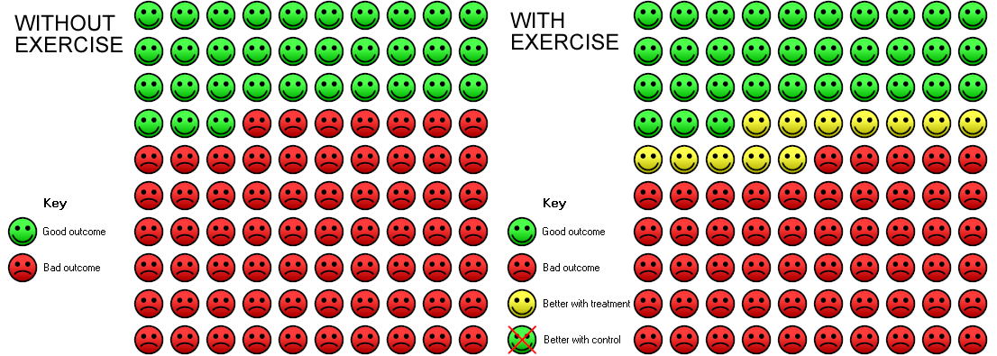
- Arthritis Research UK booklet for patients called ‘Keep Moving’ - http://tinyurl.com/keepmovingleaflet
- Arthritis Research UK poster - http://tinyurl.com/keepmovingposter
What’s the best exercise? Simple – the one a patient is willing to do. So, talk to the patient and determine how likely they are to do what you suggest. What are the limiting factors? Find a workable solution WITH the patient. Success with small steps breeds success for doing more!
Lose weight
- Losing weight – only 6kg loss needed!
- Use change talk rather than ‘telling’ them to lose weight. – where they are literally talking themselves into losing weight (motivational interviewing). Telling them to lose weight merely results in patients explaining why they can't lose weight – talking themselves out of it. How you do this…..
- DESIRE - I would like to lose weight
- ABILITY - I might be able to cut down a bit
- REASONS - I know I would feel better
- NEED - I really do need to get

Medication
- 1st line
  - Topical NSAIDs as good as oral NSAIDs but safer.
- 2nd line
  - Capsaicin topical – knee and hand OA; use small amount.
  - Oral NSAIDs – Use Naproxen with/after food - advise of GI, liver, cardiac and renal risks. Lowest effective dose shortest amount of time. Co-prescribe PPI? Beware if already on aspirin – use something else other than NSAIDs
  - IA steroids – good evidence for knee OA – reduces pain. NNT around 3-5; v good.

Glucosamine:
DO NOT PRESCRIBE ON THE NHS. Glucosamine and chondroitin (separately or combined) only reduce pain by a very small amount. However, on average they do reduce pain. This may hide a greater benefit for some people and a lesser effect for others. If glucosamine is taken, it should be as the sulphate at a dose of 1500 mg a day. The evidence is to be reviewed by NICE and their potentially revised recommendation is awaited.
Other things
- Footwear – snug fitting shoes so feet don’t slide around. Well cushioned insoles as shock absorbers.
- Contralateral cane use – improves walking. Refer to physio or OT for measurement and advice on use.
- Joint replacement – great for hips. New Zealand scores?
  - NHS patient decision aid for OA knee: http://sdm.rightcare.nhs.uk/pda/osteoarthritis-of-the-knee
  - NHS patient decision aid for OA knee: http://sdm.rightcare.nhs.uk/pda/osteoarthritis-of-the-hip

Leaflets
- Arthritis Research UK
- Arthritis Care

Prognosis.
- OA does not inevitably get worse – the course is generally intermittent with flare ups. It can even improve. (4 outcomes – intermittent flareups/remissions, stay the same, get worse, improve!)
- Painful OA hands – settles after a few years.
- OA knee can improve and only 30% get progressive disease.
- OA hip: 25% need a hip replacement after 4y of seeing GP for the first time. The other 75% won’t.

Diagnosis
Diagnose clinically on 4 things (i.e. without the need for x-ray)
- Patient over 45y
- Pain >3m worse with use (often intermittent with flare ups, patient presents during flare ups)
- No prolonged morning stiffness as in RhA (i.e. morning stiffness is less than 30 mins)
- An alternative diagnosis is unlikely.

X-rays
- Not needed for diagnosis.
- OA changes on x-ray in people over the age of 60 is NOT abnormal; just like skin becoming more wrinkly as we get older is NOT abnormal.
- In addition, in older people, OA changes on x-ray do not always correlate with their functional ability or pain. There are many older people out there who have no problems with their joints or their abilities (despite x-rays pointing to OA). And even the amount of pain does not correlated with the degree of OA on x-ray! So, don’t label people as OA just from x-rays; look at what they can and cannot do.
- Only do x-rays if there is diagnostic uncertainty – and not to confirm your diagnosis! For example, it’s okay to do hip x-ray if you suspect OA there and you think that is the cause of the knee pain.

Examination
- Examine affected joint AND the joint above and below.
- Look, feel, move – move the it through its full range.
- Often not much to see. May see some of the things below…
  - Knee
    - crepitus – hand over patella, ask patient to rise from sitting
    - medial compartment OA – bow legged (genu varum)
    - advanced OA – fixed flexion deformity
  - Hip
    - Early sign – reduced internal rotation
    - Later – reduced external rotation
  - Hands
    - DIP Heberden’s nodes, PIP Bouchards nodes
    - Tenderness at and squaring of base of thumb (common site for OA)
    - Pts may describe instability on movements of the thumb
    - Pain on axial loading through the thumb.

Explanations
- Rather than wear and tear, use tear, flare and repair or wear and repair.
- Incorporates the concept that OA does not inevitably get worse and the joint tries to repair itself. Different joints have different prognoses. For instance, in the initial phases, OA joint pains in the hands can be bad and later settles down.
- And there’s something we can do to help. Joints are living tissue and can repair themselves and we need to help them by minimising the stress on them through (i) rest (ii) lose weight (iii) exercises to correct malalignment through muscle strengthening (iv) avoid injury – sports/occupation (v) tablets to reduce pain/inflammation (topical NSAIDs or paracetamol).
- A good explanation: OA is not just wearing out of the joint. The whole joint is affected – the bones wear out a bit and the cartilage, the capsule, the ligaments and the muscles start weakening. But the joint recognises this and will try and repair itself by building new bone and cartilage and things – but it won’t do this very well if we don’t help it (through things like rest, muscle building exercises, reducing the load on the knee through things like exercise and so on).

